a | b | c | d | e | f
g | h | i | j | k | l
m | n | o | p | q | r
s | t | u | v | w | x
y | z
th | sh | ch | wh | ph | ck
ar | or | er | ir | ur | ng
ai | ay | ee | ea | oa | ow
oe | igh | ie | ou | oi | oy
dge | tch | oo | ui | ue | ew

kn | wr | gn | gh | mb | qu
aw | au | ei | ey

a | b | c | d | e | 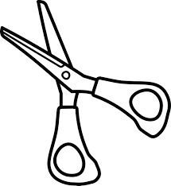  f
g | h | i | j | k | l
m | n | o | p | q | r
s | t | u | v | w | x
y | z
th | sh | ch | wh | ph | ck
ar | or | er | ir | ur | ng
ai | ay | ee | ea | oa | ow
oe | igh | ie | ou | oi | oy
dge | tch | oo | ui | ue | ew

kn | wr | gn | gh | mb | qu
aw | au | ei | ey

